2022 4-H Project “Interview” Evaluations
OHIO STATE UNIVERSITY EXTENSION
Schedule for Pre-Fair and Fair Judging Days

NON LIVESTOCK 4-H PROJECT JUDGING

Thursday July 14- Day & Evening Judging
Specific Project times/ location will be available closer to date of judging.
91 Discovering 4-H
92 4-H Around The Globe
173 Horseless Horse
244 Vet 1 – From Airedales to Zebras
245 Vet 2 – All Systems Go
246 Vet 3 – On the Cutting Edge
300 You’re the Athlete
351 Staying Healthy
352 Keeping Fit
353 First Aid in Action
354 Medicine Science & Safety
355 Tracking Your Health & Fitness
357 Alcohol and Drug Abuse
358 The Truth about Tobacco
359 Your Thoughts Matter
434 Superhero You
405 The Laundry Project
406 Clothes for High School & College
407 Accessories for Teens
408 Creative Costumes
409 Sew Fun
410 Designed By Me
411 em●bel●ish: 4-H Guide to Wearable Art
412 Sew for Others
413 Sundresses and Jumpers
415 Ready, Set, Sew Active
417 Dress-Up Outfits
418 Loungewear
419 Terrific Tops
420 Outerwear for Anywhere
424 Clothing for Middle School
425 Look Great for Less
426 Clothing for your Career
430 Shopping Savvy
432M Sewing Master
442 Family History Treasure Hunt
445 Becoming Money Wise
448 Teens… On the Road to Financial Success
459 Let’s Start Cooking
461 Let’s Bake Quick Breads
462 Yeast Breads on the Rise
463 Sports Nutrition: Ready, Set, Go
467 You’re the Chef
OHIO STATE UNIVERSITY EXTENSION
469 Global Gourmet
472 Grill Master
474 Beyond the Grill
475 Star Spangled Foods
476 Kitchen Boss
477 Party Planner
481 Everyday Food and Fitness
484 Snack Attack
485 Racing the Clock Awesome Meals
486 Dashboard Dining
487 Take a Break for Breakfast
491 It’s My Home
492 Cake Decorating Project/Record Book
494 Make Over My Space
495 Your First Home Away From Home- Online
496 My Favorite Things
497 Scrapbooking
498 Quilting the Best Better
499 You Can Quilt
541 Crank It Up
542 Warm It Up
543 Tune It Up
556 Measuring Up
557 Making the Cut
558 Nailing it Together
559 Finishing Up
560 Woodworking Master
551 Tractor 1: Starting Up
552 Tractor 2: Gearing Up for Safety
553 Tractor 3: Moving Out
554 Tractor 4: Learning More
592 Get Started in Art
593 Seeing Through Graphic Design
670 Canning and Freezing
671 How Does Your Garden Grow
673 Edible Landscapes
691 Grow Your Own Vegetables
692 Growing with the Seasons

Saturday July 16- Day Judging
Specific Project times/ location will be available closer to date of judging.
215 Cavy Project and Record Book
216 Cats 1 – Purrr-fect Pals
217 Cats 2 – Climbing Up
218 Cats 3 – Leaping Forward
200 All About Dogs
201 Dogs- All Trainings
220 Pocket Pets

365 Self Determined- Choose your own topic or select an idea starter topic

Self-Determined Projects– MAY be judged at Thursday judging depending on topic to be eligible for the Ohio State Fair. If you are not choosing a project idea starter for your Self-Determined Project, please notify the extension office of your project topic by May 1st.

365.00 General
- 3-D Printing
- Amateur Radio
- American Sign Language
- Clowning
- Computers
- Disability Advocacy and Awareness
- Discovering Genetics
- Local Foods: Does It Matter What You Eat?
- Model Railroading
- Music
- PhysBot- Your 4-H Fitness Tracker
- Skateboarding
- Viruses, Bacteria, and Fungi, Oh My!
- Ways of Knowing Water

365.01 Companion Animal
- Hedgehogs
- Ferrets
- Chinchillas
- Pigeons
- Reptiles and Amphibians

365.02 Creative Arts
- Miniature Gardens- Fairies, fake plants, etc.
- Paper Craft
- String Art

365.03 Family Life
- Babysitting

365.04 Natural Resources
- Astronomy
- Bats
- Climate Change
- Crop Production
- Field to Faucet: What determines water quality
- Flower Gardening
- Getting Started with Composting
- Going Green: Lead a Sustainable Life
- Miniature Gardens- Live Plants
- Native American Artifacts: Arrowheads
- Paddle Water Sports
- Shale Gas Extraction
- Weather

365.05 Quilt

365.06 Workforce Preparation
- Camp Counseling
- The Work World is Calling…Are You Ready?

370 Mentoring: Leadership in Action
371 Club Leadership 1
372 Diversity: The Source of Our Strength
373 My Hands to Larger Service: Teen Leaders Building Our Communities
374 Teens on Board
375 Leadership Road Trip: Where are you going?
376 Pantry Panic
377 Finding Your Voice: Public Speaking Made Easy
378M Leadership Master
382 Am I Ready To Work
383 Club Leadership 2
387 Here, There, Ag Careers Everywhere
490 Science Fun with Dairy Foods: Case of the Missing Milk
493 Science Fun with Kitchen Chemistry
500 Science Fun with Physics
501 Rockets Away (2 liter bottle)
502 Science of Flight
503 Rockets Away (Solid Fuel Model Rockets)
503M Rocketry Master
507 Robotics 1 with Lego EV3
508 Robotics 2 EV3N More
512 Robotics Master
517 Bicycling for Fun, level 1
518 Wheels in Motion, level 2
527 Magic of Electricity, level 1
528 Investigating Electricity, level 2
529 Wired for Power, level 3
530 Entering Electronics, level 4
531 Science Fun With Electricity
540 Not Just Knots
550 Young Engineers in Solar Energy
555 ATV Safety
573 Arcs and Sparks
584 Photography Basics, Book 1
585 Next Level Photography, Book 2
586 Mastering Photography, Book 3
589M Photography Master
588 The Writer in You
611 Explore the Outdoors
612 Geology: Can You Dig It?
613 Exploring Polar Science
617 Exploring Ponds
620 Why Trees Matter
621 Ohio Birds
622 Trapping Muskrats in Ohio
623 Outdoor Adventures: Beginning Fishing
624 Outdoor Adventures: Intermediate Fishing
630 Safe Use of Guns
631 Basic Archery
641 Beekeeping
644 Insect Adventures 1
645 Insect Adventures 2
646 Insect Adventures 3

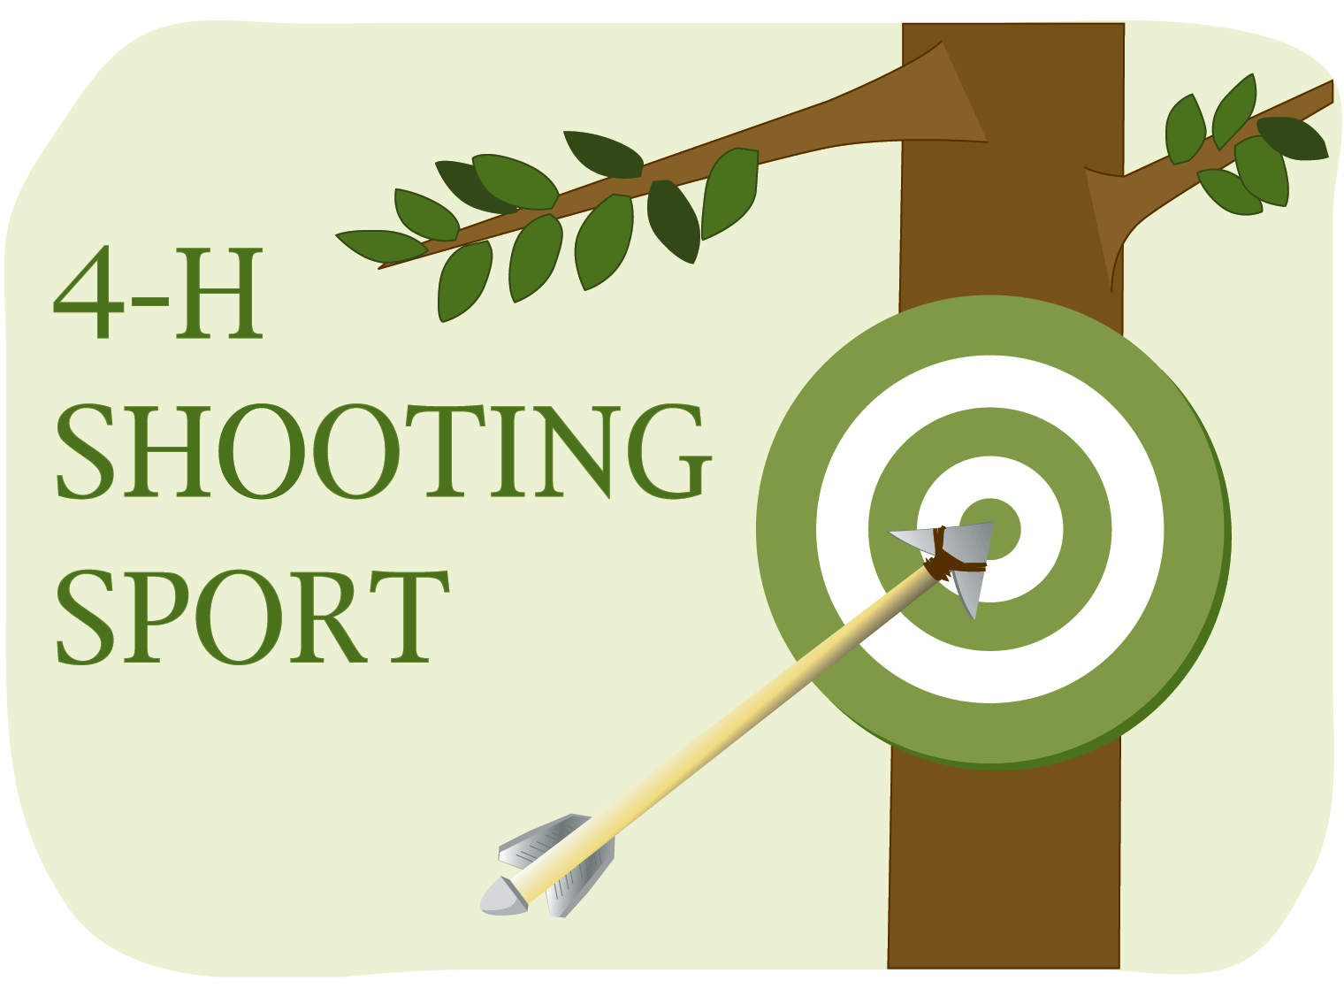

Currently Crawford County is not offering any of the advanced shooting sports projects below:
Archery Shotgun
Pistol Rifle
Muzzleloader Living History
Crossbow

Youth interested in shooting sports CAN enroll in 630 Safe Use of Guns and/ or
631 Basic Archery
LIVESTOCK SKILLATHON- TBA
(Project Books and County Record Books)

Skillathon is required for ALL 4-H LIVESTOCK EXHIBITORS. The competitive (test) portion of skillathon will again be optional in 2022.

117M Market Beef
117B Pilot Beef Breeding
117BF Beef Feeder Calf
117DF Dairy Beef Feeder
122 Dairy Calves & Heifer
126 Dairy Cows & Management
132 Llamas and Alpacas
135D Goat - Dairy
135F Goat - Fiber
135H Goat - Harness
135M Goat -Meat
135PA Goat -Pack
135PY Goat – Pygmy
135C Goat- Companion/ Pet
139 Market Hog
140 Swine Breeding
150CE Chicken, Exhibition
150CM Chicken, Market
150CEP Chicken, Egg Production: Hens & Pullets
150DE Duck, Exhibition
150DM Duck, Market
150GE Goose, Exhibition
150GM Goose, Market
150TE Turkey, Exhibition
150TM Turkey, Market
150H Helmeted, Guinea Fowl
198 Market Lamb
199 Sheep Breeding
225 Breeding Rabbit
226 Market Rabbit
227 Pet Rabbit

HORSE SKILLATHON- TBA
Skillathon is required for ALL 4-H HORSE EXHIBITORS. Bring both your record book and project book completed to skillathon.

174 Beginning Horse Management
175 Light Horse Selection
177 Basic Horse Training
180 Learning to Jump
181 Draft Horse
182 Small Equine
184 Standardbred Horses
185 Equine Reproduction
188 Trail Riding
189 Dressage
762 Horse Nutrition

